**SCREEN PRINT OF MS-POWERPOINT**

Shortcut toolbar

Formatting toolbar

Title bar

Menu bar

Windows control button

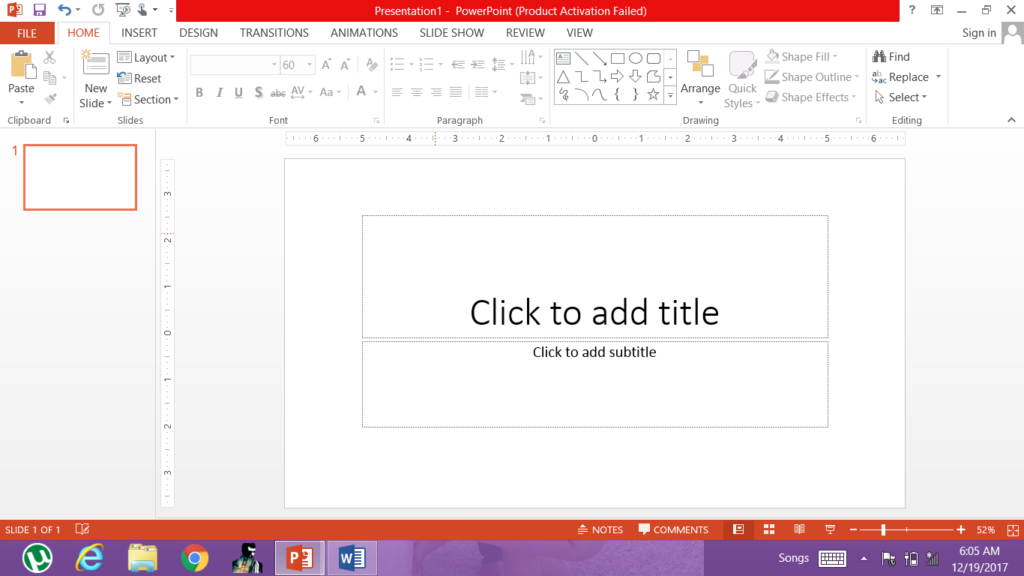

Notes area

Zoom pan

Slide view

Scale

Status bar

Thumbnails